**Hotel Booking System**

**Test Results**

Date: 11/30/16

Christopher Paradiso

Thomas Soutar

Justin Teutonico

# Introduction

This document will detail the results of us trying out our Hotel Booking System application.

# Testing Process:

## Account creation tests

* An admin was created with username “admin”.

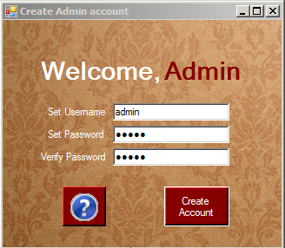

* The admin account created a hotel manager account, named “hotelmanager”, and a kitchen manager account, named “kitchenmanager”.

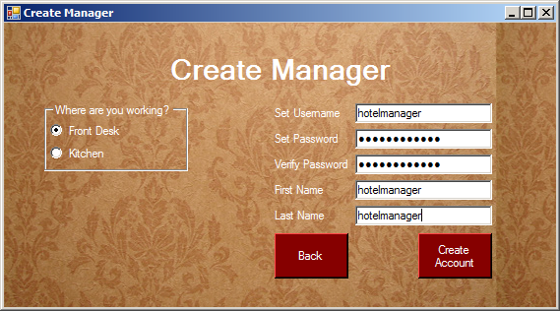

* Hotel and restaurant employee accounts were created, named “hotelemployee” and “kitchenemployee”, respectively.

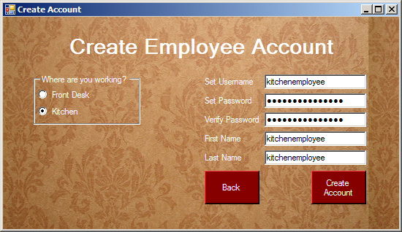

## Hotel Manager test

* The manager can create and edit rooms.
* A room was added to the hotel, named “Room 101”, costing $90 per night.
* The room was edited to be named “Room 100”.

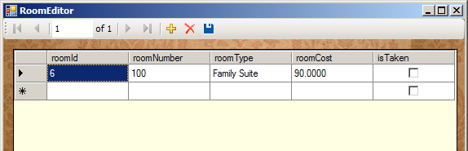

## Kitchen Manager test

* The manager can create and edit items on the menu.
* “Pasta” was added to the food section of the menu for $12.50, and “Pepsi” was added to the drink section for $2.50.
* The food was edited to be “Spaghetti” and the drink was edited to be “Coke Cola”.

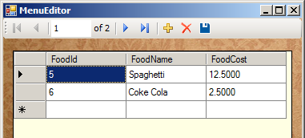

## Hotel Employee test

* Hotel Employees can see available rooms, add and edit reservations, and finalize bills.
* The room that the manager previously made is viewable.

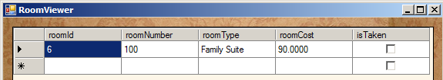

* A reservation was created for the room.
* The family name of the family was “Smith”, and the first name of the person making the reservation was “John”
* John’s address is 2800 Victory Blvd, SI NY, email is “johnsmith@cix.csi.cuny.edu”
* John arrives on Jan 1, and leaves Jan 2, or one night.
* He has a standard room type and its number is 100.
* The total cost for his stay is $90.

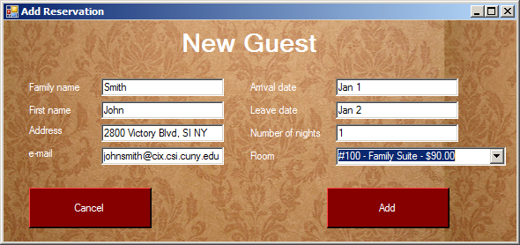

## Kitchen Employee test

* This employee can check the menu, add or edit an order, and finalize a bill.
* The menu was examined.
* An order for John Smith, room 100, was added.
* The order was Spaghetti and Coke Cola, totaling $15.00
* The bill was finalized and sent to John.

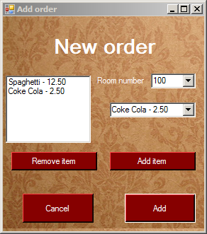

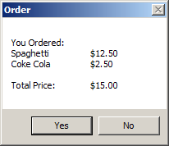

## General login

* From the general login screen, the user can input their name and password.
* A fake username and password was entered, which the system rejected.

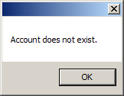

* Next, we inserted the login information for every person we’ve created thus far.
* We were able to log in to everyone and do their functions.
* Lastly, the program was quit by clicking the “x” in the top right corner of the application.

# Conclusions

* Every account type can be logged into and used.
* Every account can do their individual functions.
* The interface is clear and easy for the user to use, with clear instructions throughout the program.