Hotel Booking System™

User Manual

Christopher Paradiso

Thomas Soutar

Justin Teutonico

In this quick-start guide, you will learn:

* How to create accounts for your Hotel Management System™
* How to train your employees to use the Hotel Management System™
* Navigate through the Hotel Management System™ software quickly and easily

# First time startup

Before you can use this software, an administrator account must be created. This account can only be created once, so take caution. The administrator account will be needed whenever a new manager is added to your Hotel.

Launch The executable file, and enter the username and password of the system administrator.

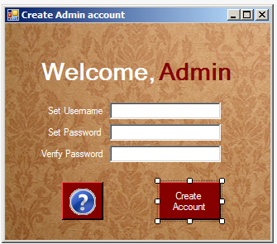

# Adding managers

To create a manager account, log into the administrator account and select “Create Manager”. From there, have the manager fill in their username, password, name, and working area.

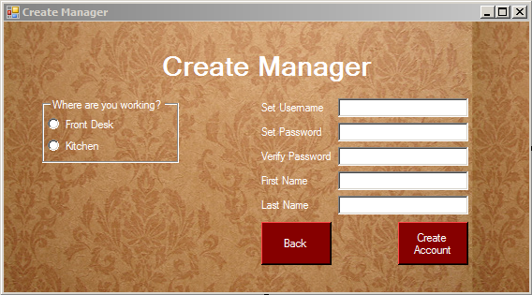

# Adding employees

Anyone can add an employee from the login screen. Simply click on “Create Account” and have the employee fill in their username, password, name, and working area.

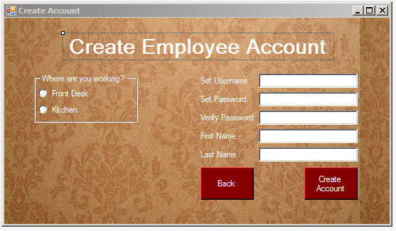

# Editing the database

Managers will need to edit database values for each hotel room or each room service item. Editing a database is simple:

1) Click on a value right of the ID

2) Enter a valid value; this could either be text or a number

3) When finished editing the database, click on the disk icon to save.

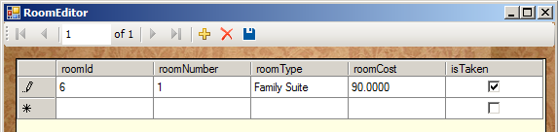

# Checking in a guest

To check in a guest, one must first log in as a main desk employee. From the menu, choose the option “New Guest”. Either the guest can enter their own information, or the employee can transfer the record from paper.

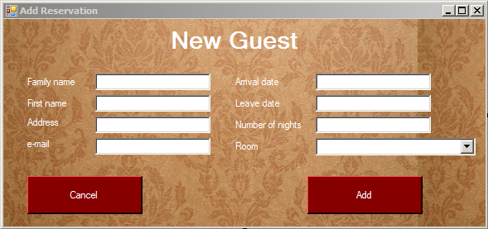

# Checking out a guest

To check out a guest, log in as a main desk employee and select “Check Out/Finalize Bill”. Choose from the drop down menu which guest to check out and click “Check Out”. Note: This system does not support credit card processing.

# Room service order

To make an order, one must first log in as a kitchen employee and select “New Order”. From there, the employee can enter the customer's room number and items ordered. When finished, click on “Add”, and the order will be added to the guest's bill.

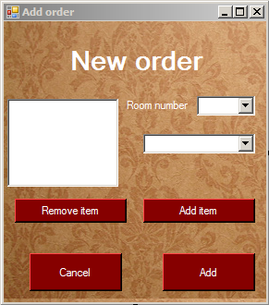

# Fixing a mistake

If a mistake is ever made, a main desk employee can fix it by editing the guest database. Click on “Guest Editor/Viewer” and follow the same instructions as in “Editing the database”.

# Software map



# Security features

To protect the database and employee information, the following features have been added to the software:

- The password is hidden when types

- The password is encrypted in the database

# Resetting the software

To reset the software, either use a .mdf editor to clear all database values, or reload the software as a fresh install.

# Resetting admin account

If you want to reset the admin account while keeping other database values, a .mdf editor must be used to delete the admin from the database. The next time the software starts, you will see the create admin screen instead of the standard login.