Hotel booking system
Product Design Specification
Version 2.0
11/23/2016

Christopher Paradiso
Thomas Soutar
Justin Teutonico

introduction
This document will describe the object-oriented architecture of the Hotel Booking System software. It will also describe a detailed look into the GUI interface. This project uses the C# programming language, using Visual Studio 2013. The following features will be used in this project:
- Polymorphism
- GUI Interface
- SQL Database

Architecture Design

class structure
This project contains a total of 3 class objects:
- Item
- Order
- Room

item class
The item class contains the following variables:
- double price
- string itemName
The item class contains the following accessors:
- double Price (get/set)
- string ItemName (get/set)
The item class contains the following functions:
- Item()
- Item(double, string)
- string formattedPrice()

order class
The order class contains the following variables:
- int roomNumber
The order class contains the following accessors:
- int RoomNumber (get/set)
The order class contains the following lists:
- List<Item> itemList
The order class contains the following functions:
- Order()
- Order(int)
- void add(Item)
- void remove(Item)
- void remove(int)
- double totalPrice()
- string formattedTotalPrice()
- bool display()

room class
The room class contains the following variables:
- int roomNumber
- string roomType
- double roomCost
The room class contains the following accessors:
- int RoomNumber (get/set)
- string RoomType (get/set)
- double RoomCost (get/set)

logical view

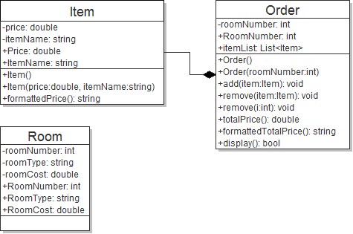

user interface design
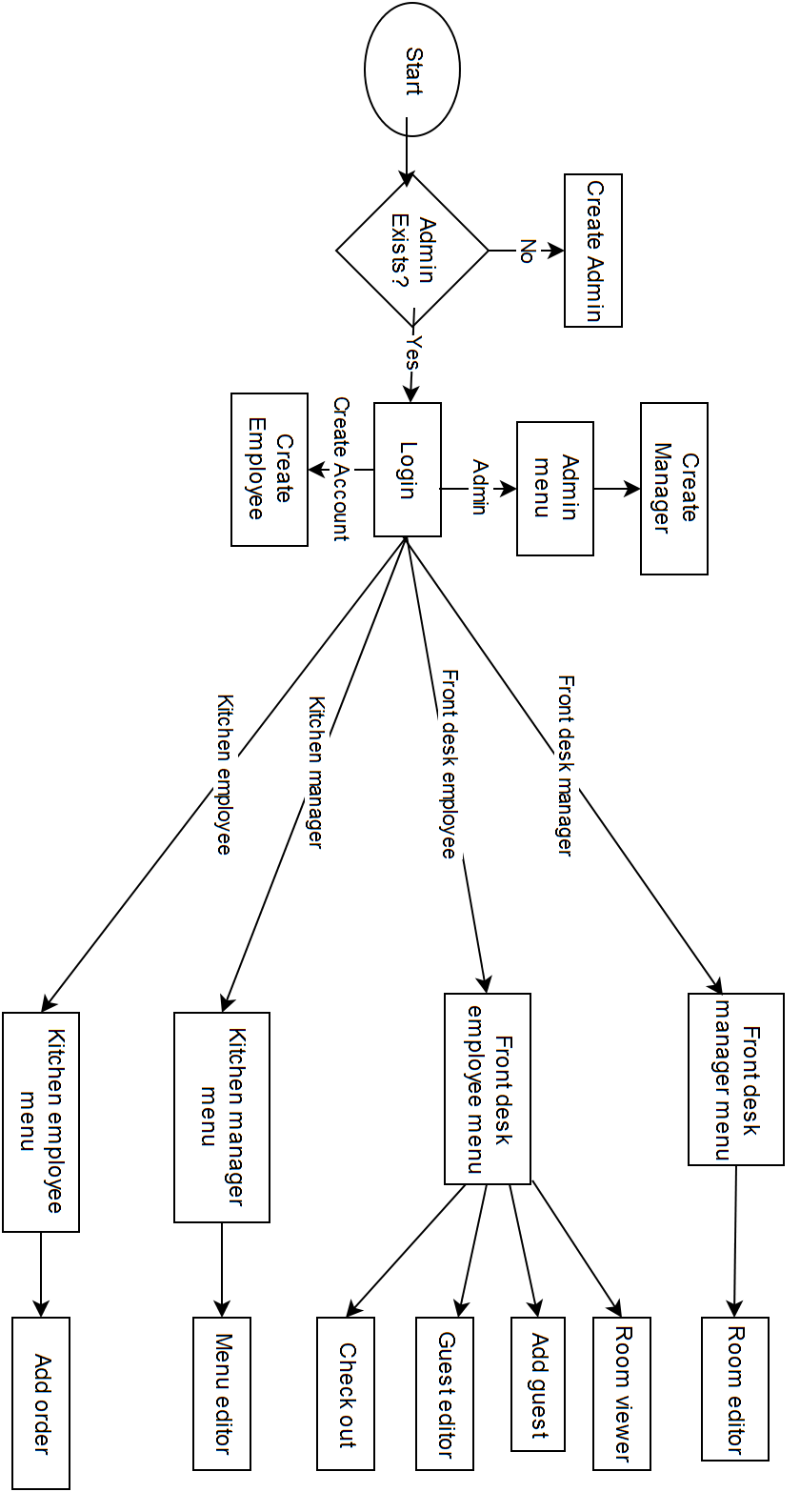

application program interfaces

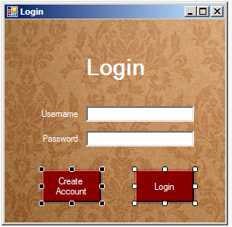
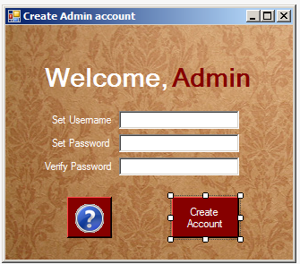

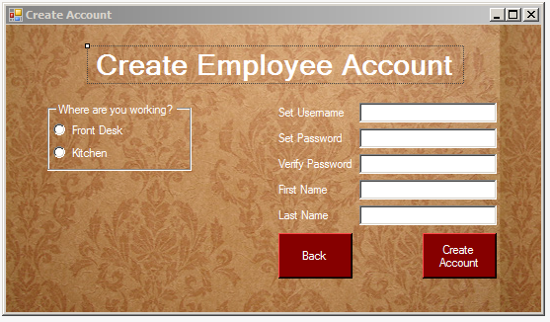

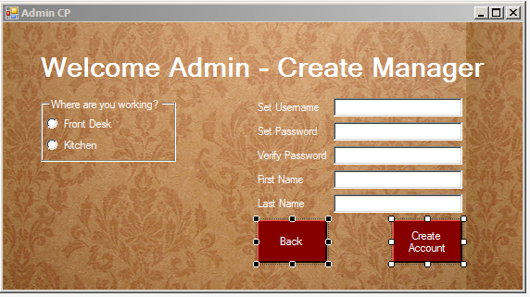

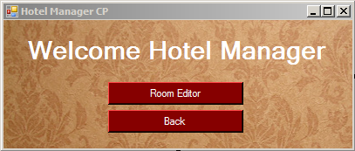

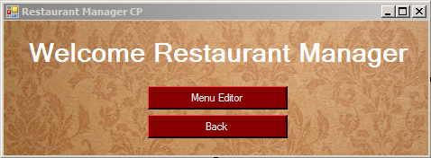

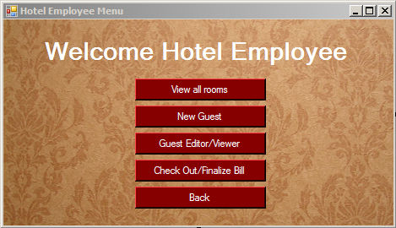

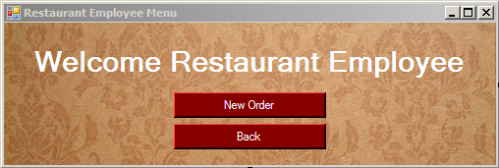

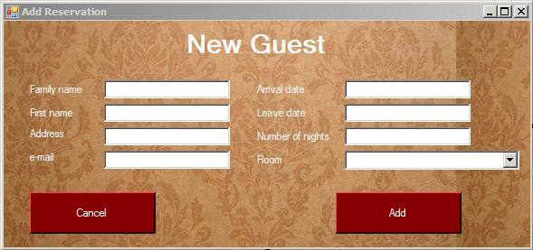
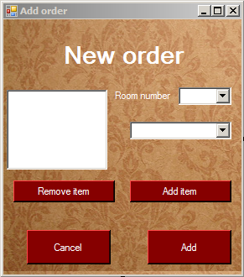

database design
User database
userID | username | password | firstname | lastname | type
1 | Admin | [encrypted] | Admin | Admin | Admin
… | … | … |  |  | …
Guest database
guestId | lastName | firstName | address | email
1 | Smith | John | 2800 Victory Blvd, SI NY | John.Smith@cix.csi.cuny.edu
… | ... | … | … | ...
(Guest database continued)
arrivalDate | leaveDate | numberofNights | roomType | roomNumber | totalCost
1/1/2016 | 1/2/2016 | 1 | Family Suite | 100 | 90
… | … | … | … | … | ...
Room Database
roomId | roomNumber | roomType | roomCost | isTaken
1 | 1 | Family Suite | 90 | False
… | … | … | ... | …
Menu Database
FoodId | FoodName | FoodCost
1 | Hamburger | 7.99
… | … | …

